**VISVESVARAYA TECHNOLOGICAL UNIVERSITY**

**BELAGAVI**

**-**

**590018**

**A MINI PROJECT REPORT ON**

**“**

**PHARMACY**

**MANAGEMENT SYSTEM”**

**Submitted By**

**YASEER HUSSAIN**

**115**

**RA20CS**

**4**

**SANDEEP**

**RA20CS**

**4**

**085**

**To the Visvesvaraya Technological University during the academic year**

**2022**

**-**

**23**

**in**

**partial fulfilment for the award of**

**DATABASE MANAGEMENT SYSTEMS**

**)**

**(**

**V SEMESTER**

**In**

**COMPUTER SCIENCE ENGINEERING**

**Under the Guidance of**

**Mrs. SHRUTHI**

**Assistant P**

**rofessor,**

**Dept**

**.**

**of CSE**

**Rajeev Institute Of Technology**

**Hassan**

**RAJEEV INSTITUTE OF**

**TECHNOLOGY**

**DEPARTMENT OF INFORMATION**

**SCIENCE AND ENGINEERING**

**HASSAN**

**-**

**573201**

**2022**

**-**

**2023**



(Approved by AICTE, New Delhi and Affiliated to VTU, Belagavi.)

Plot #1-D, Growth Centre, Industrial Area, B-M Bypass Road, Hassan –573201

Ph:(08172)-243180/83/84 Fax:(08172)-243183

573201 Ph:(08172)-243180/83/84 Fax:(08172)-243183

Department of Computer Science and Engineering

**RAJEEV**

**INSTITUTE OF TECHNOLOGY**

**CERTIFICATE**

This

Certified that the project work entitled “

PHARMACY

MANAGEMENT

SYSTEM” is carried out by Mr

.

YASEER HUSSAIN

[4RA20CS115

and

M.r SANDEEP

20

[4

RA

CS085

]

respectively,

bonafide

a

RAJEEV INSTITUTE

OF

students

of

TECHNOLOGY, Hassan in partial fulfillment for the subject DATABASE MANAGEMENT

SYSTEMS in

COMPUTER

SCIENCE AND ENGINEERING of the Visvesvaraya

Technological University, Belagavi during the year 2022

-

2023

. The mini project re

port has

been approved as it satisfies the academic requirements in respect of mini project work

prescribed for the said Degree.

_______________ ________________ ________________

Mrs. SHRUTHI H.S Dr.

PRA

KASH H N

Dr. MAHESH P.K

Assistant Professor Head of the Department Principal

Dept. of CSE Dept. of

CSE

RIT HASSAN

RIT HASSAN RIT

HASSAN

**Name of Examiners**

**S**

**ignature**

**of Examiners with date**

**1.**

**2**



**DECLARATION**

We **Yaseer Hussain** and **Sandeep** students of 3rd year B.E in **Computer Science** **and Engineering** , Rajeev Institute of Technology , Hassan , here by declare that the working being presented in the dissertation entitled “**Pharmacy Management System**” embodies report of our mini project work carried out independently by us under the guidance of **Mrs. Shruthi H S** , Assistant Professor , Computer Science and Engineering , Rajeev Institute of Technology , Hassan , as partial fulfilment of requirement for the award of B.E degree . This mini project has not been submitted for the award of any degree in any other University.

Yaseer hussain [4RA20CS115] Sandeep [4RA20CS085]

PLACE: HASSAN

DATE:

**ACKNOWLEDGEMENT**

The satisfaction and euphoria that accompany the successful of any task would be incomplete without the mention of the people who made it possible, whose constant guidance and encouragement crowned our efforts with success.

We would like to profoundly thank our Management of RIT & our President **Dr. Rachana** Rajeev for providing such a healthy environment.

We would like to express our sincere thanks to our principal **Dr. Mahesh P.K**, Rajeev Institute of Technology for his encouragement.

We wish to express our gratitude to **Dr. H.N Prakash**, Head of the Department of CSE for providing a good working environment and for his constant support and encouragement.

It gives us great pleasure to express our gratitude to **Mrs. Shruthi H S** Assistant Professor, Department of CSE for her expert guidance, initiative and encouragement that lead us to complete this project.

We would also like to thank all our staffs of Computer Science and Engineering department who directly or indirectly helped us in the successful completion of this project and also, we would like to thank our parents.

**Yaseer Hussain Sandeep**

**4RA20CS115 4RA20CS085**

# ABSTRACT

A Pharmacy database management system is a computerized system that is used to manage the information and data related to pharmacy .This system is designed to help pharmacists and other health care professionals keep track of patients, medications, and other important information in an efficient and organized manner. The system typically includes features such as electronic prescription management, inventory management and drug interactions checks among others. With the pharmacy database management system ,pharmacists can improve patient safety and reduce the risk of errors , while also streamlining operations and improving overall efficiency .

**Table of Contents**

Abstract i

Acknowledgements ii

Table of Content iii

List of Figures iv

List of Tables v

**Chapters Page No.**

**1. INTRODUCTION**

1.1 Introduction to pharmacy Management System1

**2. SOFTWARE REQUIREMENTS SPECIFICATION**

2.1 Specific Requirements 2

2.1.1 Software Requirements 2

2.1.2 Hardware Requirements 3

2.1.3 Non functional Requirements 4

**3.1 DATABASEDESIGN**

3.1 E-R Diagram 6

3.2 Schema Diagram 9

**4. RESULTS** 11

**5. CONCLUSION AND FUTURE ENHANCEMENT**

5.1 Conclusion 24

5.2 Future Enhancement 25

**6. REFERENCES** 26

**List of Figures**

**Figure Name**

**Fig 1.1: Simplified database environment system**

**Fig 1.2: Architecture of DBMS**

**Table 2.1 Structure of ADMIN**

**Table 2.2 Structure of CASHIER**

**Table 2.3.1 Structure of ids**

**Table 2.3.4 Structure of INVOICE**

**Table 2.3.5 Structure of INVOICE_DETAILS**

**Table 2.3.6 Structure of PHARMACIST**

**Table 2.3.7 Structure of PRESCRIPTION**

**Table 2.3.8 Structure of RECIEPT**

**Table 2.3.9 Structure of SALES**

**Table 2.4 Structure of STOCK**

**Table 2.5 Structure of TEMPPRESCRI**

**Table 2.6 date on prescription trigger**

**Table 2.7 Date on receipt Trigger**

**Table 2.8 Stored procedure getCashier**

**Table 2.9 Stored procedure getPharmacist**

**Fig 3.1: ER diagram**

**Fig 3.2: Schema Diagram in 3rd normal form**

**FIG A.1 Database Connection**

**FIG A.2 Input Query**

**FIG A.3 Select Query**

**FIG A.4 Update Query**

**FIG A.5 Delete Query**

**FIG B.1 LOGIN Page**

**FIG B.2 Admin Login Page**

**FIG B.3 Admin_Pharmacist Page**

**FIG B.4 Admin_Cashier Page**

**FIG B.5 PHARMACIST Home Page**

**FIG B.6 Pharmacist Prescription Page**

**FIG B.7 PHARMACIST STOCK PAGE**

**FIG B.8 Casheir Home Page**

**FIG B.9 Cashier Payment Page**

**CHAPTER – 1**

# INTRODUCTION

## 1.1 Introduction to DBMS

Database and database technology has a major impact on the growing use of computers. It is fair to say that databases play a critical role in almost all areas where computers are used, including business, electronic commerce, engineering, medicine, genetics, law, education, and library science. The word database is so commonly used that we must begin by defining what the database is.

Our initial definition is quite general. A database is a collection of related data. By data, we mean known facts that can be recorded and that have implicit meaning. For example, consider the names, telephone numbers, and addresses of the people you know. You may have recorded this data in an indexed address book or you may have stored it on a hard drive, using personal computers and software such as Microsoft excel. This collection of related data with an implicit meaning is a database.

The preceding definition of a database is quite general, for example, we may consider the collection of words that make up this page of text to be related data and hence to constitute a database. However, the common use of the term database is usually more restricted. A database has the following properties:

* A database represents some aspect of the real world, sometimes called the mini world or the universe of discourse. The changes to the mini world are reflected in the database.
* A database is a logically coherent collection of data with some inherent meaning. A random assortment of data cannot correctly be referred to as a database.
* A database is designed, built and populated with data for a specific purpose. It has an intended group of users and some preconceived applications in which these users are interested.

In other words, a database has some source from which data is derived, some degree of interaction with events in the real world, and an audience that is actively interested in its contents. The end-users of the database may perform business transactions (for example a customer buys a camera) or events may happen that may cause the information in the database to change. In order for a database to be accurate and reliable at all times, it must be a true reflection of the mini world that it represents; therefore changes must be reflected in the database as soon as possible.

* 1. database can be of any size and complexity. A database may be generated and maintained manually or computerized. For example, a library card catalog is a database that may be created and maintained manually. A computerized database may be created and maintained either by a group of application programs written specifically for that task or by a database management system.

A database is a collection of data, typically describing the activities of one or more related organizations. For example, a university database might contain information about the following:

* Entities such as students, faculty, courses, and classrooms.
* Relationships between entities, such as student’s enrolment in courses, faculty teaching courses, and the use of rooms for courses.
  1. database management system, or DBMS, is software designed to assist in maintaining and utilizing a large collection of data. The need for such systems as well as their use is growing rapidly. The alternative to using a DBMS is to store the data in files and write application-specific code to manage it.

## File system versus DBMS

To understand the need for a DBMS, let us consider a motivating scenario: a company has a large collection (say 500 GB) of data on employees, departments, products, sales, and so on. This data is accessed concurrently by several employees. Questions about the data must be answered quickly, changes made to the data by different users must be applied consistently and access to certain parts of the data must be restricted. We can try to manage the data by storing it in operating system files. This approach has many drawbacks, including the following

* We probably do not have 500GB of main memory to hold all the data. We must, therefore, store data in a storage device such as a disk or tape and bring relevant parts into the main memory for processing as needed.
* Even if we have 500 GB of main memory, on computer systems with 32 bit addressing, we cannot refer directly to more than about 4 GB of data. We have to program some method of identifying all data items.

* We have to write special programs to answer each question a user may want to ask about the data. These programs are likely to be complex because of the large volume of data to be searched.
* We must protect the data from the inconsistent changes made by different users accessing the data concurrently. If applications must address the details of such concurrent access, this adds greatly to their complexity.
* We must ensure that the data is restored to a consistent state if the system crashes while changes are being made.
* Operating systems provide only a password mechanism for security. This is not sufficiently flexible to enforce security policies in which different users have permission to access different subsets of the data.

A DBMS is a piece of software designed to make the preceding tasks easier. By storing data in DBMS rather than as a collection of operating system files, we can use the DBMS’s features to manage the data in a robust and efficient manner. As the volume of data and the number of users grow hundreds of gigabytes of data and thousands of users are common in current corporate database DBMS support becomes indispensable.

## 1.1 DATABASE ENVIRONMENT SYSTEM

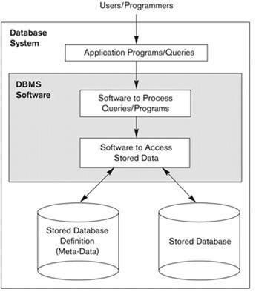

**Fig 1.1: Simplified database environment system**

A database management system (DBMS) is a collection of programs that enables users to create and maintain a database. The DBMS is a general-purpose software system that facilities the processes of defining, constructing, manipulating and sharing databases among various users and applications. Defining a database involves specifying the data types, structures and constraints of the data to be stored in the database.

The database definition or description information is also stored by the DBMS in the form of a database catalog or dictionary, it is called Metadata. Constructing the database is the process of storing the data on some storage medium that is controlled by the DBMS. Manipulating a database includes functions such as querying the database to retrieve specific data, updating the database to reflect changes in the mini world and generating reports from the data. Sharing a database allows multiple users and programs to access the database simultaneously.

An application program accesses the database by sending queries or requests for data to DBMS. A query typically causes some data to be retrieved; a transaction may cause some data to be read and some data to be written into the database.

Other important functions provided by DBMS include protecting the database and maintaining it over a long period of time, protection includes system protection against hardware or software malfunction and security protection against unauthorized or malicious access. A typical large database may have a life cycle of many years, so the DBMS must be able to maintain the database system by allowing the system to evolve as requirements change over time.

It is not absolutely necessary to use general-purpose DBMS software to implement a computerized database. We could write our own set of programs to create and maintain the database, in effect creating our own special purpose DBMS software. In either case, whether we use a general-purpose DBMS or not we usually have deployed a considerable amount of complex software. In fact, most DBMSs are very complex software systems. Fig 1.1 shows a simplified database environment system.

### 1.2 ADVANTAGES OF USING DBMS APPROACH

Using a DBMS to manage data has many advantages:

* **Data Independence:** application program should not, ideally, be expected to detailsof data representation and storage, the DBMS provides an abstract view of the data that hides such details.

* **Efficient Data Access:** A DBMS utilizes a variety of sophisticated techniques to storeand retrieve data efficiently. This feature is especially important if the data is to be stored on an external device.

* **Data Integrity and Security:** if data is always accessed through DBMS, the DBMScan enforce integrity constraints. For example, before inserting salary information for an employee, the DBMS can check that the department budget is not exceeded. Also, it can enforce access controls that govern what data is visible to different classes of users.

* **Data Administration:** when several users share data, centralizing the administrationof data can offer significant improvements. Experienced professionals who understand the nature of the data being managed, and how different groups of users use it, it can be responsible for organizing the data representation to minimize redundancy and for finetuning the storage of the data to make retrieval efficient.

* **Concurrent Access and Crash Recovery:** A DBMS schedules concurrent accessesto the data in such a manner that users can think of the data as being accessed by only one user at a time. Further, the DBMS protects users from the effects of system failures.

* **Reduced Application Development Time:** clearly, the DBMS supports importantfunctions that are common to many applications accessing data in the DBMS. This, in conjunction with the high-level interface to data, facilities quick application development. DBMS applications are also likely to be more robust than a similar standalone application because many important tasks are handled by the DBMS.

**1.3 ARCHITECTURE OF DATABASE**

### The Three-Schema Architecture

The goal of the three-schema architecture illustrated in the figure is to separate the user application from the physical database. In this architecture, schemas can be defined at the following three levels:

* The internal level has an internal schema, which describes the physical storage structure of the database. The internal schema uses a physical data model and describes the complete details of data storage and access paths for the database.
* The conceptual level has a conceptual schema, which describes the structure of the whole database for a community of users. The conceptual schema hides the details of physical storage structures and concentrates on describing entities, data types, relationships, user operations, and constraints. Usually, a representational data model is used to describe the conceptual schema when a database system is implemented. This implementation conceptual schema is often based on a conceptual schema design in a high-level data model.
* The external or view level includes a number of external schemas or user views. Each external schema describes the part of a database that a particular user group is interested in and hides the rest of the database from that user group. As in the previous level, each external schema is typically implemented using a representational data model, possibly based on external schema design in a high-level data model.

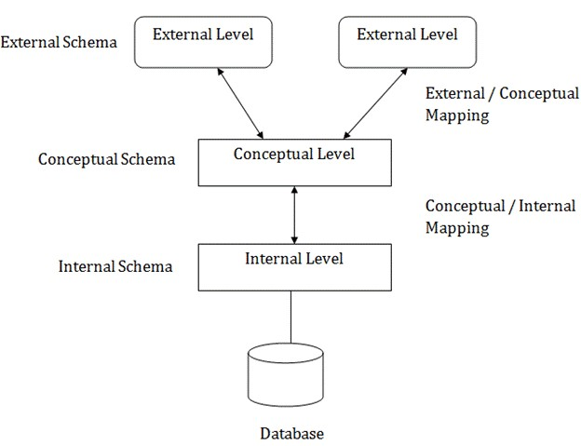

**Fig 1.2: Architecture of DBMS**

**CHAPTER 2**

# INTRODUCTION TO PROJECT

## 2.1 BRIEF DESCRIPTION

The mini-project entitled “PHARMACY MANAGEMENT SYSTEM “ is developed as a part of the fifth semester DBMS laboratory, for the partial fulfillment of the requirement for the BE( Information Science) course.

### Project Description

The project entitled Pharmacy Management System this is developed for established Medical store in the city. To manage all operations of the medical store this project is being developed. It will have the entire basic module to manage the medical store operations.

### Objectives

The main objective of the application is to automate the existing system of manually maintained records of the counter sales, purchases, reorder levels, Supplier and Customer monetary positions and other related transactions made by the seller.

## 2.2 SCOPE

This application can be used by any other store to automate the process of manually maintaining the records related to the subject of maintaining the stock and liquid flows.

# 2.3 TABLE DESCRIPTION

## 2.3.1 ADMIN

ADMIN table has the admin_id, admin_username, admin_password and admn_id is used as the primary key as shown in Table 2.1.

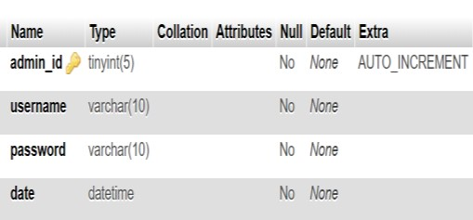

**Table 2.1 Structure of ADMIN**

## 2.3.2 CASHIER

Cashier table has the casier_id,first_name,last_name,staff_id,postal_address,phone,email, username,password,date.cashier_id is used as a primary key attribute as shown in Table 2.2.

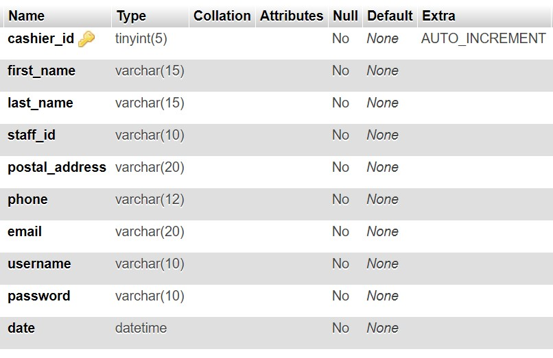

**Table 2.2 Structure of CASHIER**

## 2.3.3 IDS

ids table has user_id,ids,invoice_id and user_id is used as primary key as shown in Table 2.3.

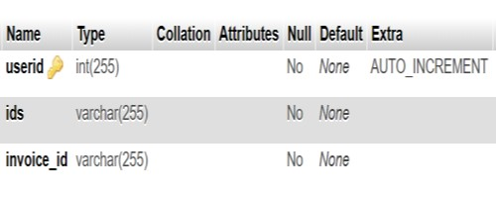

**Table 2.3 Structure of ids**

## 2.3.4 INVOICE

INVOICE table has the attributes id,invoice_id,customer_name,served_by,status,date and id is used as primary key as shown in Table 2.4.

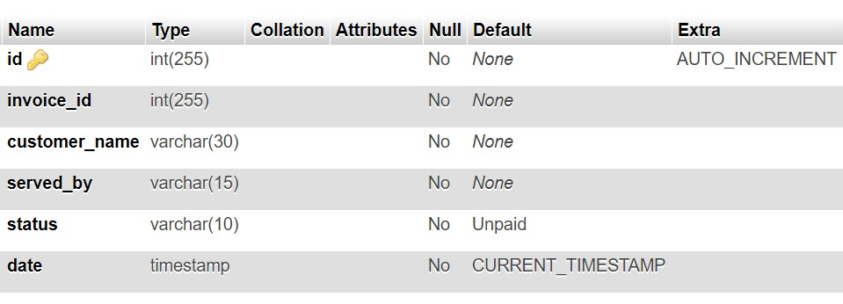

**Table 2.4 Structure of INVOICE**

## 2.3.5 INVOICE_DETAILS

INVOICE_DETAILS table has the attributes id,invoice,drug,cost,quantity,day,month,year And id is the primary keys as shown in Table 2.5.

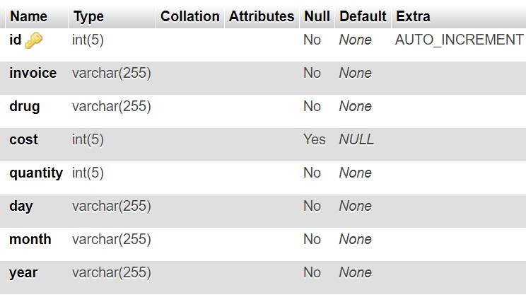

**Table 2.5 Structure of INVOICE_DETAILS**

## 2.3.6 PHARMACIST

PHARMACIST table has the attributes pharmacist_id,first_name,last_name,staff_id, postal_address,phone,email,username,password,date and pharmacist_id is the primary keys as shown in Table 2.6.

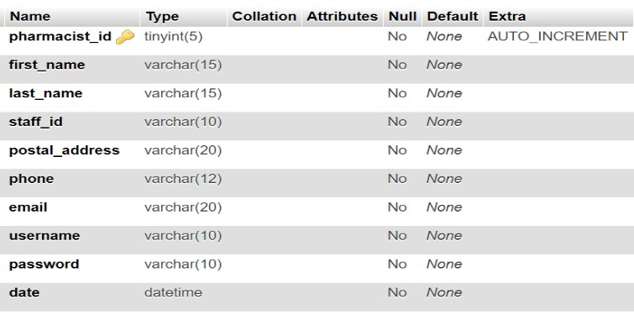

**Table 2.6 Structure of PHARMACIST**

## 2.3.7 PRESCRIPTION

PRESCRIPTION table has the attributes id,prescription_id,customer_id,customer_name, invoice_id,phone,date and pharmacist_id and id is the primary keys as shown in Table 2.7.

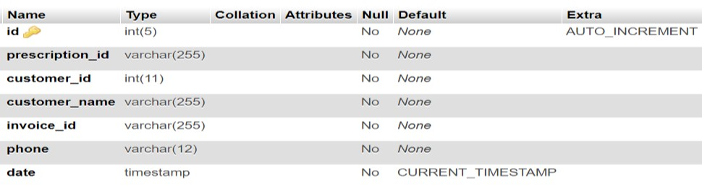

**Table 2.7 Structure of PRESCRIPTION**

## 2.3.8 RECIEPT

RECIEPT table has the attributes reciptNo,customer_id,total,payType,serialno,served_by,

Date and reciptNo is the primary keys as shown in Table 2.8

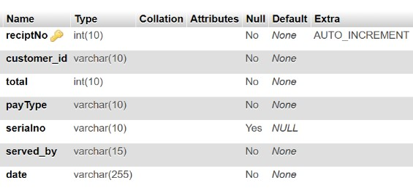.

**Table 2.8 Structure of RECIEPT**

## 2.3.9 SALES

SALES table has the attributes userid,invoice,drug,cost,quantity,day,month,year and userid is the primary keys as shown in Table 2.9

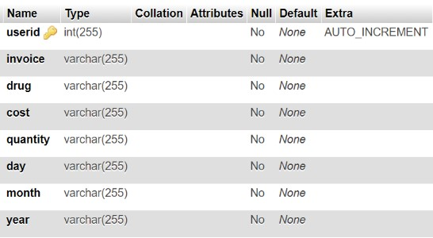

**Table 2.9 Structure of SALES**

## 2.3.10 STOCK

STOCK table has the attributes stock_id,drug_name,category,description,company,supplier and strength,quantity,cost,status,date_supplied and stock_id is the primary keys as shown in Table 2.10

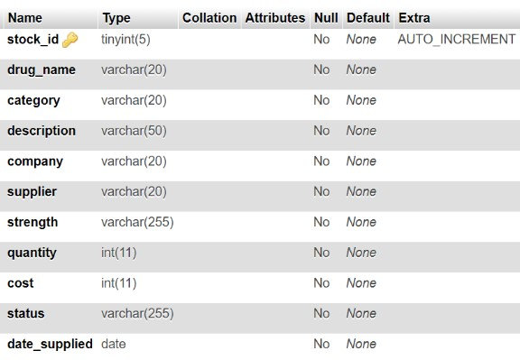

**Table 2.10 Structure of STOCK**

## 2.3.11 TEMPPRESCRI

TEMPPRISCRI table has the attributes userid,customer_id,customer_name,phone, drug_name,strength,dose,quantity and stock_id is the primary keys as shown in Table 2.11

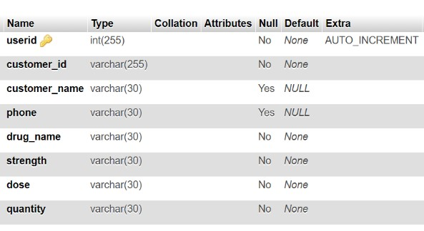

**Table 2.11 Structure of TEMPPRESCRI**

## 2.4 TRIGGERS

A trigger is a special type of stored procedure that automatically executes when an event occurs in the database server.

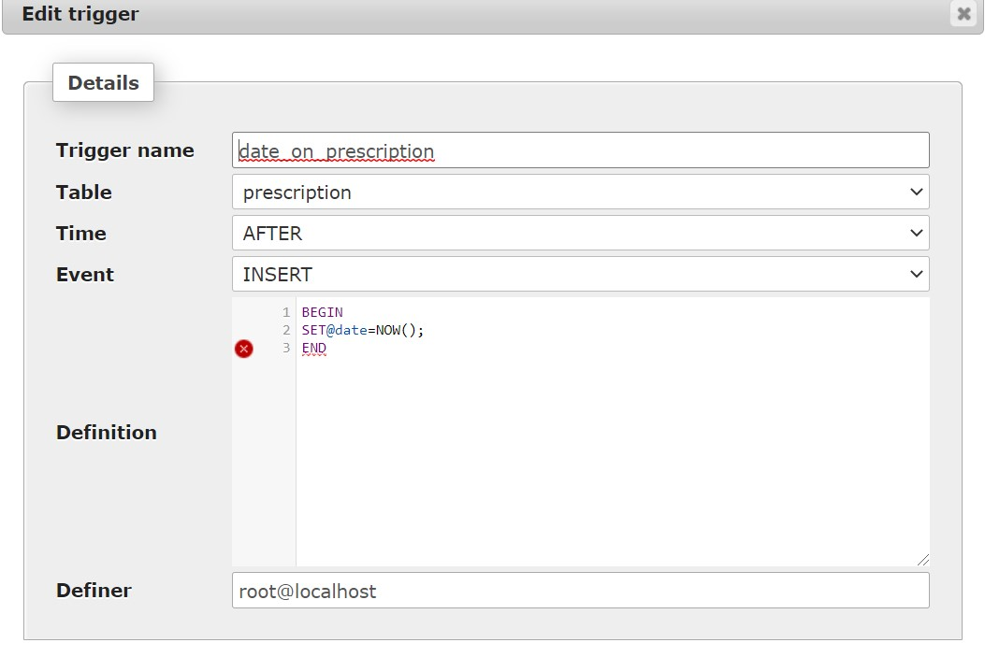

**Table 2.6 date on prescription trigger**

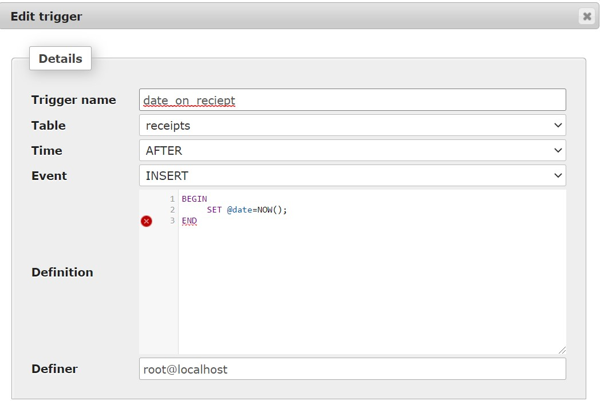

**2.7 Date on receipt Trigger**

In this project, two triggers called date_on_prescription and date_on_reciept as shown in Table 2.6 and Table 2.7 are used to set an attribute called date in the table receipt and prescription table before insertion and before updation respectively.

## 2.5 STORED PROCEDURE

A stored procedure is a set of Structured Query Language (SQL) statements with an assigned name, which is stored in a relational database management system as a group, so it can be reused and shared by multiple programs.

In this project, a stored procedure called getCashier, as shown in Table 2.8, is used to set an attribute from all the users of Cashier in table Cashier

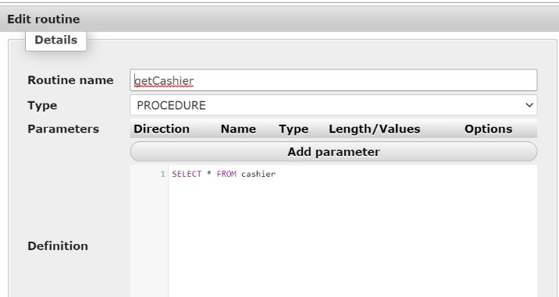

**Table 2.8 Stored procedure getCashier**

In this project, a stored procedure called getCashier, as shown in Table 2.9, is used to set an attribute from all the users of Pharmacist in table Pharmacist

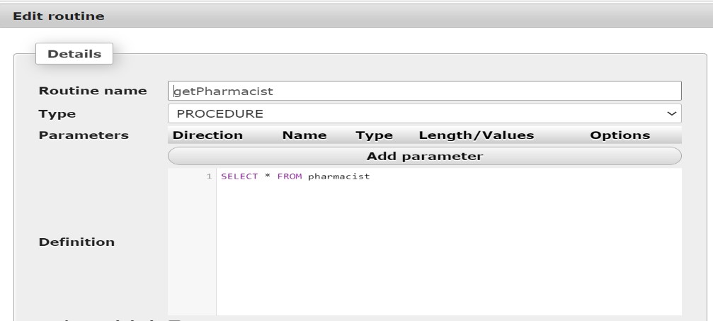

**Table 2.9 Stored procedure getPharmacist**

**CHAPTER 3**

# DESIGN

**3.1 ENTITY RELATIONSHIP DIAGRAM:**

ER Relationship model allows us to describe the data involved in a real-world enterprise in terms of objects and their relationship widely used to develop an initial database design. It is primarily important in its role in database design.

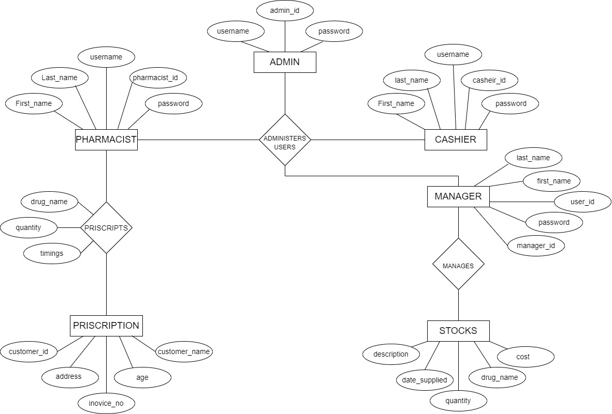

**Fig 3.1: ER diagram**

In this ER Diagram shown in Fig 3.1 Entities ADMIN,PHARMACIST,CASHIER,

PRESCRIPTS,PRESCRIPTION and STOCK are represented by rectangles, attributes of the tables are represented by ovals and relationships are represented using diamonds.

## 3.2 NORMALIZATION

### 3.3.1 First Normal Form (1NF)

As the domain of all attributes of all relations in the database has atomic value and no tuples can have a set of these values, all relations are in 1NF.

### 3.3.2 Second Normal Form (2NF)

As there is no partial dependency in the database, i.e. all nonprime attributes of a relation are fully functionally dependent on the primary key of the relation schema, all relations are in 2NF.

### 3.3.3 Third Normal Form (3NF)

As all relations are in 2NF and no non-prime attribute of a relation schema is transitively dependent on the primary key, all relations are in 3NF.

## 3.3 SCHEMA DIAGRAM

A database schema can be represented in a visual diagram, which shows the database object and their relationship which represents the logical view of the database and how the relationships among them are represented.

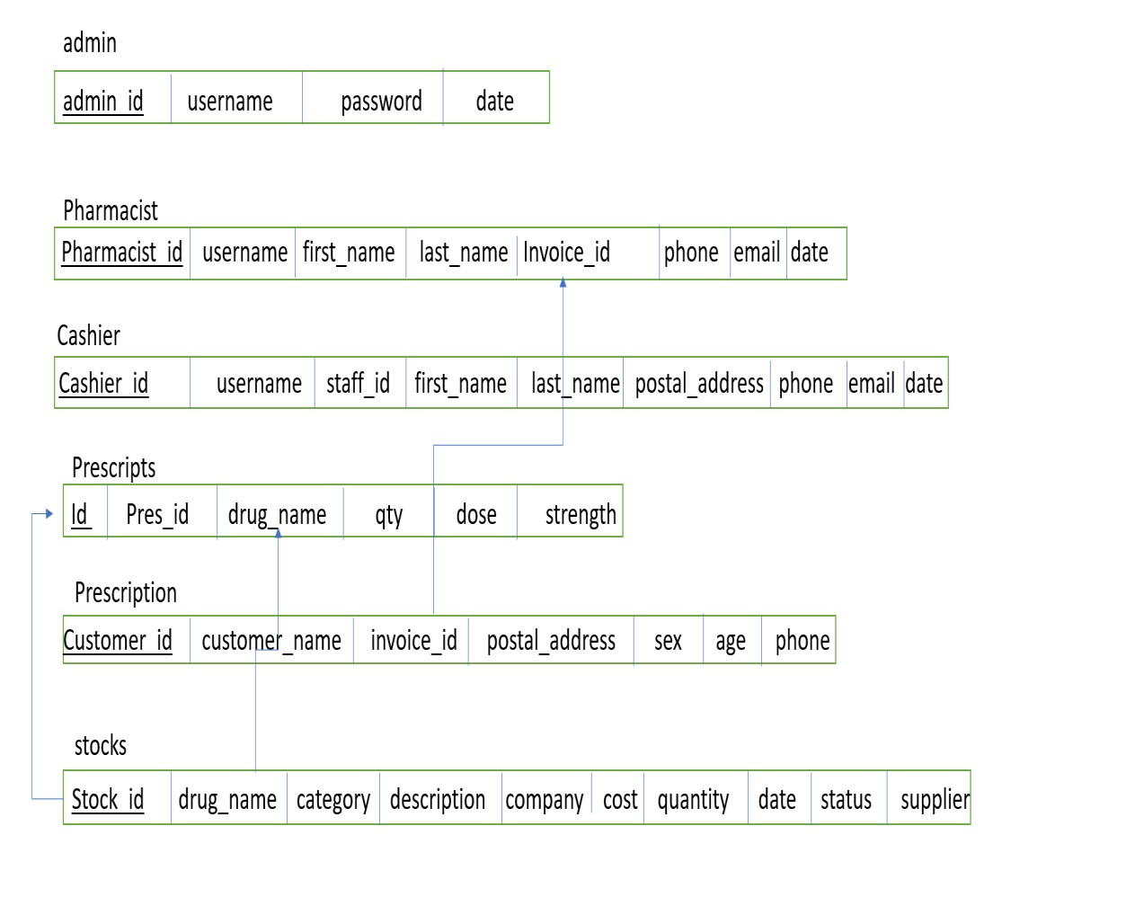

**Fig 3.2: Schema Diagram in 3rd normal form.**

This Schema Diagram in Fig 3.2 represents different tables used and underlined attributes are primary keys and arrows are used to represent foreign keys.

## CHAPTER-4 HARDWARE AND SOFTWARE REQUIREMENTS

### 4.1 FUNCTIONAL AND NON-FUNCTIONAL REQUIREMENTS

#### 4.1.1 FUNCTIONAL OR SPECIFIC REQUIREMENTS

The required software is used for ordering food online. The system should satisfy the following requirements:

* 1. Logging into the system

* 2. Signup option

* 3. View Menu Details

* 4. Order Option

* 6. View User Orders

* 7. Logout option

#### 4.1.2 NON-FUNCTIONAL REQUIREMENTS

All of the application data is stored in an Oracle database, and therefore an Oracle Database must also be installed on the host computer. As with Apache2, this software is freely available and can be installed and run under most operating systems. The server hardware can be any computer capable of running both the web and database servers and handling the expected traffic. For a small scale restaurant that is not expecting to see much web traffic, an average personal computer may be appropriate. Once the site starts generating more hits, though, it will likely be necessary to upgrade to a dedicated host to ensure proper performance. The exact cut-offs will need to be determined through a more thorough stress testing of the system.

##### 4.1.2.1 SECURITY REQUIREMENTS

Some of the factors that are identified to project the software from accidental or malicious access, use, modification, destruction, or disclosure are described below.

* Ascertain functions to different modules
* Restrict communication between areas of the program
* Check data integrity for critical variables
* A later version of the software will incorporate encryption techniques in the user/license authentication process
* Communication needs to be restricted when the application is validating the user or license

### 4.2 HARDWARE REQUIREMENTS

* A desktop or laptop with a proper internet connection.
* 20 GB of hard disk (free space)
* Minimum 2GB or Greater of the RAM
* Windows 7 or 8 or 10 Operating system.

### 4.3 SOFTWARE REQUIREMENTS

#### 4.3.1 SERVER SIDE

1. Programming language: PHP 5.6.31
2. Web Server: Apache 2.4.27
3. Database: SQL 5.7.19

#### 4.3.2 CLIENT SIDE

1. Programming language: JAVASCRIPT, HTML, CSS
2. OS: windows7/8/10
3. MYSQL server

##### 4.3.1.1 PHP

PHP is a server-side scripting language designed primarily for web development but also used as a general programming language PHP code may be embedded into HTML or HTML5 markup or it can be used in combination with various web template systems, web content management systems, and web frameworks. PHP code is usually processed by a PHP interpreter implemented as a module in the web server. The web server software combines the results of the interpreted and executed PHP code, which may be any type of data, including images, with the generated webpage.[1]

##### 4.3.1.2 WEB SERVER: APACHE

Apache is the most widely used web server software. Developed and maintained by Apache Software Foundation, Apache is open-source software available for free. It runs on 67% of all web servers in the world. It is fast, reliable, and secure. It can be highly customized to meet the needs of many different environments by using extensions and modules. Most WordPress hosting providers use Apache as their web server software. However, WordPress can run on other web server software as well.[2]

##### 4.3.1.3 HTML

HTML is an acronym that stands for HyperText Markup Language.

**HyperText:** HyperText simply means "Text within Text". A text has a link within it, is a hypertext. Every time you click on a word that brings you to a new webpage, you have clicked on a hypertext.

**Markup language:** A markup language is a programming language that is used to make text more interactive and dynamic. It can turn a text into images, tables, links, etc. An HTML document is made of many HTML tags and each HTML tag contains different content.[3]

###### 4.3.1.4AVASCRIPT

Javascript is a dynamic computer programming language. It is lightweight and most commonly used as a part of web pages, whose implementations allow client-side script to interact with the user and make dynamic pages. It is an interpreted programming language with objectoriented capabilities.[4]

# FUTURE ENHANCEMENT

Due to the findings from carrying out this research on Pharmacy Management System, some points to consider in its implementation in the future include:

1. A platform capable of use at a regional/national level

2.Strict security measures put in place to prevent an abuse of the application in general

# APPENDIX ‘A’- CODE SNIPPETS

## A.1 DATABASE CONNECTION

The connect() / mysqli_connect() function opens a new connection to the MySQL server with the following syntax:

mysqli_connect(host, username, password, dbname);

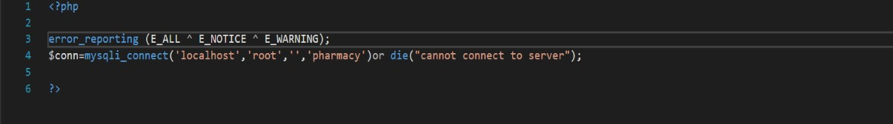

**FIG A.1 Database Connection**

## A.2 INPUT QUERY

This query is used to get the details of the cashier using INSERT querry

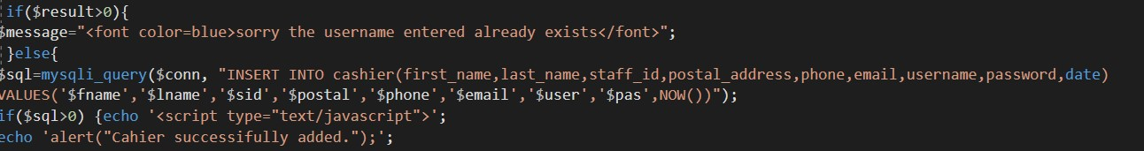

**FIG A.2 Input Query**

## A.3 SELECT QUERY

In this querry, all the details are fetched using SELECT * command



}

**FIG A.3 Select Query**

## A.4 UPDATE QUERY

Here the update query is called to update the user of an already existing based on its name and category id,address etc respectively.

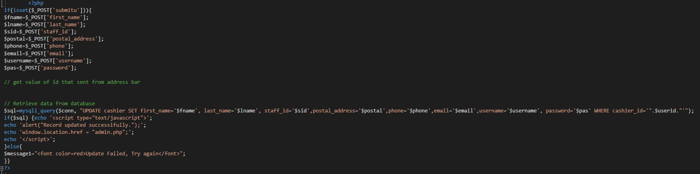

**FIG A.4 Update Query**

## A.5 DELETE QUERY

Here the delete query is called to delete a particular person based on user id, user name



**FIG A.5 Delete Query**

# APPENDIX ‘B’ – SCREENSHOTS

## B.1 LOGIN PAGE

This is the first window when the application is executed as shown in Fig B.1.

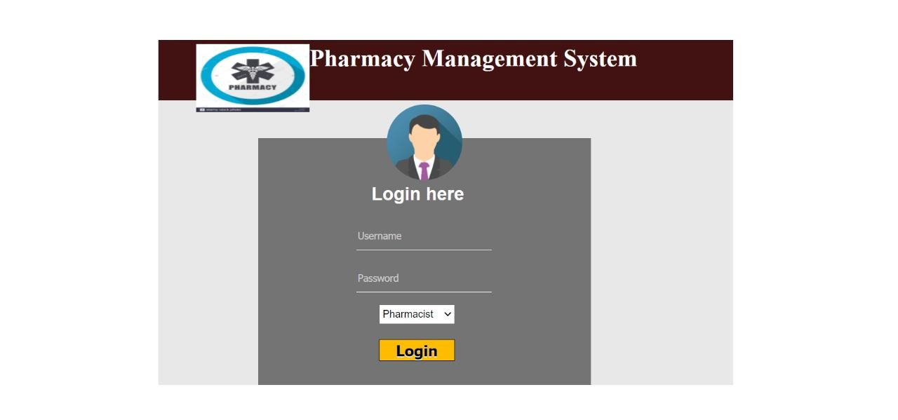

**FIG B.1 LOGIN Page**

## B.2 ADMIN HOME PAGE

On successful login, admin can either add, update or delete any user and can also view the details of all the pharmacists and cahier

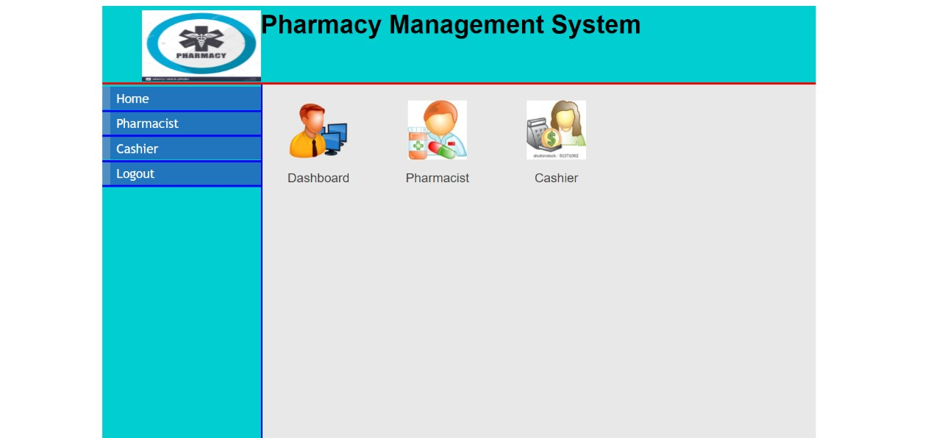

**FIG B.2 Admin Login Page**

## B.3 ADMIN_PHARMACIST PAGE

admin can access to add, update or delete any pharmacist and view their id,username,firstname and lastname in fig.B3

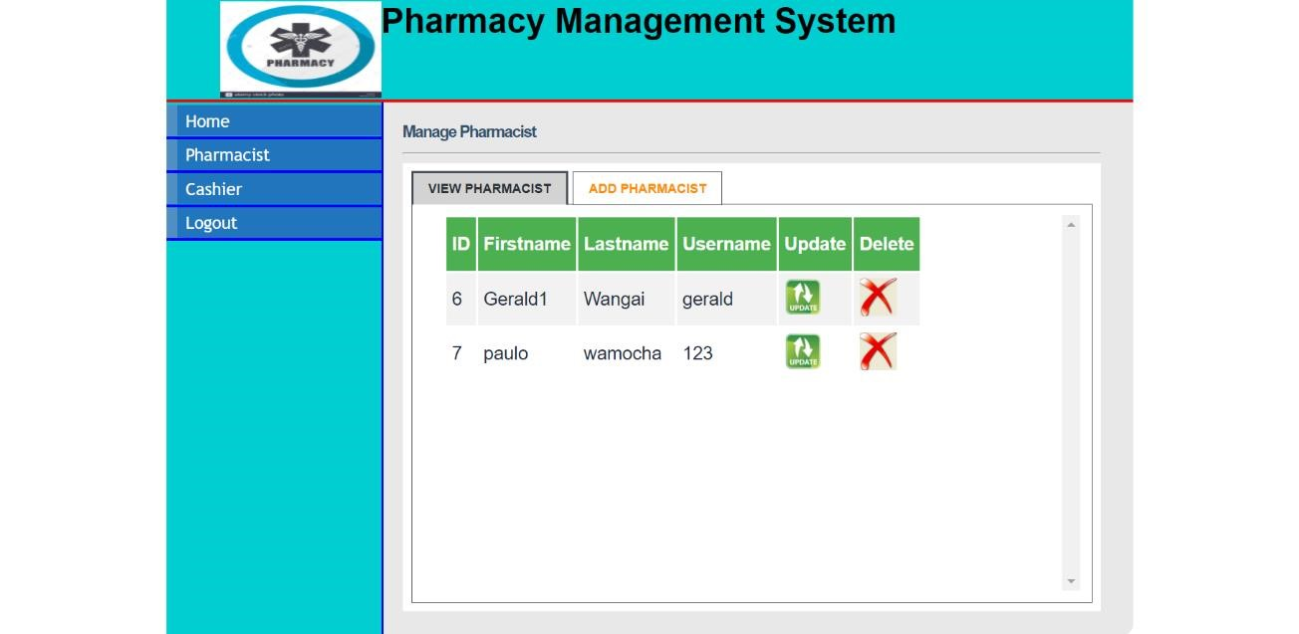

**FIG B.3 Admin_Pharmacist Page**

### B.4 ADMIN_Cashier Page

admin can access to add, update or delete any pharmacist and view their id,username,firstname and lastname Fig B.4.

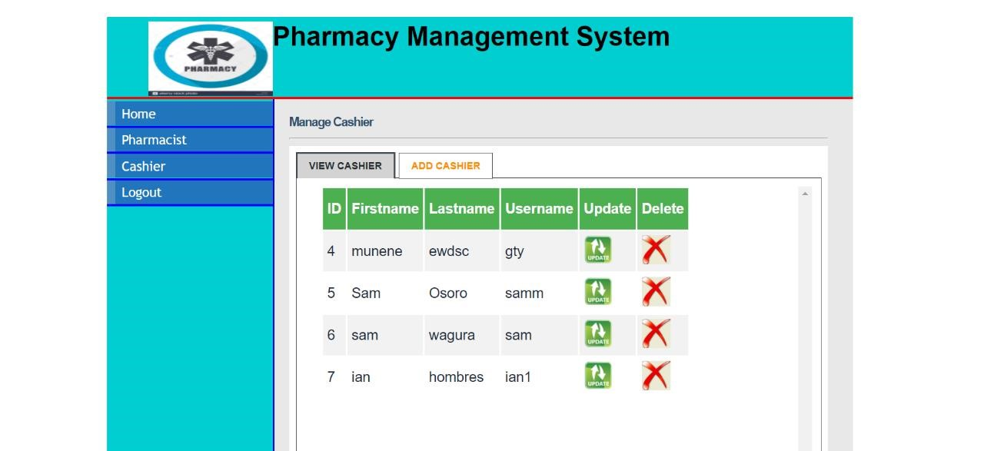

**FIG B.4 Admin_Cashier Page**

## B.5 PHARMACIST HOME PAGE

PHARMACIST can view and write prescription. And also check the availability of medicine stock shown in Fig B.6.

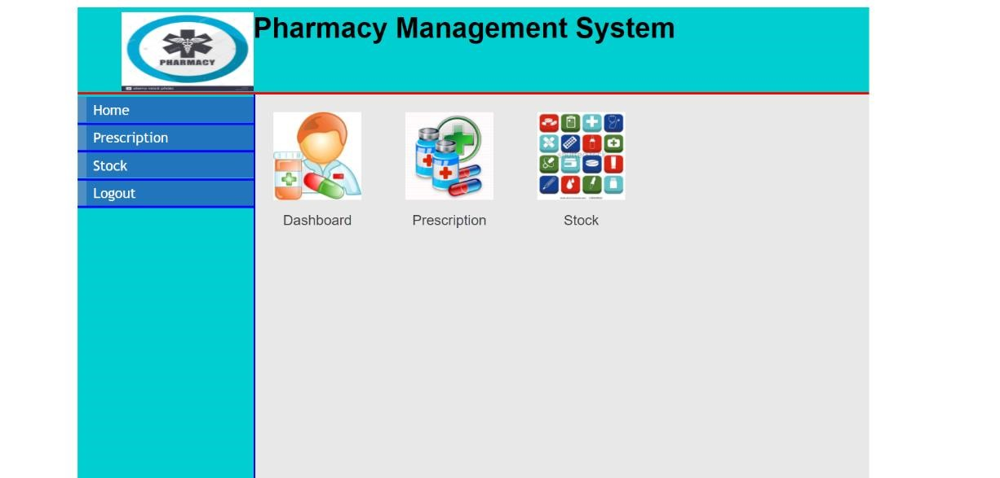

**FIG B.5 PHARMACIST Home Page**

## B.6 PHARMACIST_PRESCRIPTION PAGE

On this page, PHARMACIST can view and add the prescription ,here the invoice id will generate as shown in Fig B.6.

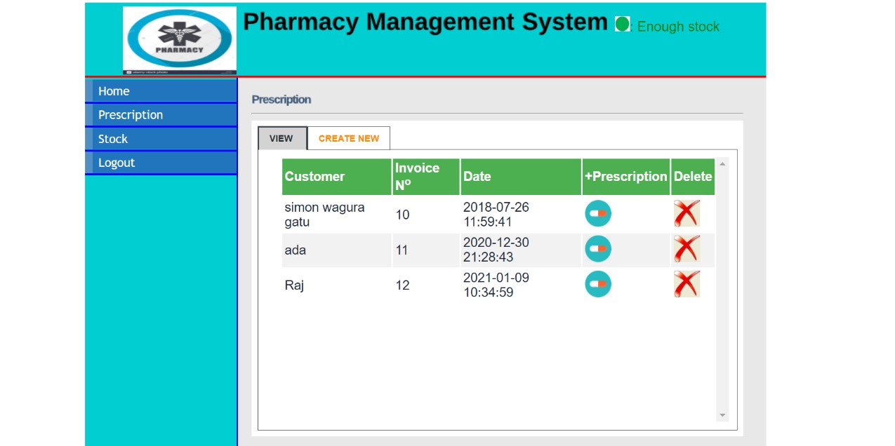

**FIG B.6 Pharmacist Prescription Page**

## B.7 PHARMACIST STOCK PAGE

On this page, Pharmacist can view the name of drugs,availability of stocks,description of drugs,availability and access to remove medicine on figB.7

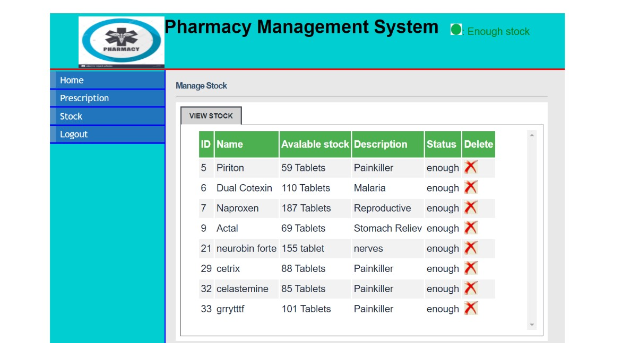

**FIG B.7 PHARMACIST STOCK PAGE**

## B.8 CASHIER HOME PAGE

On successful login,cashier can move to process payment page shown in fig B.8

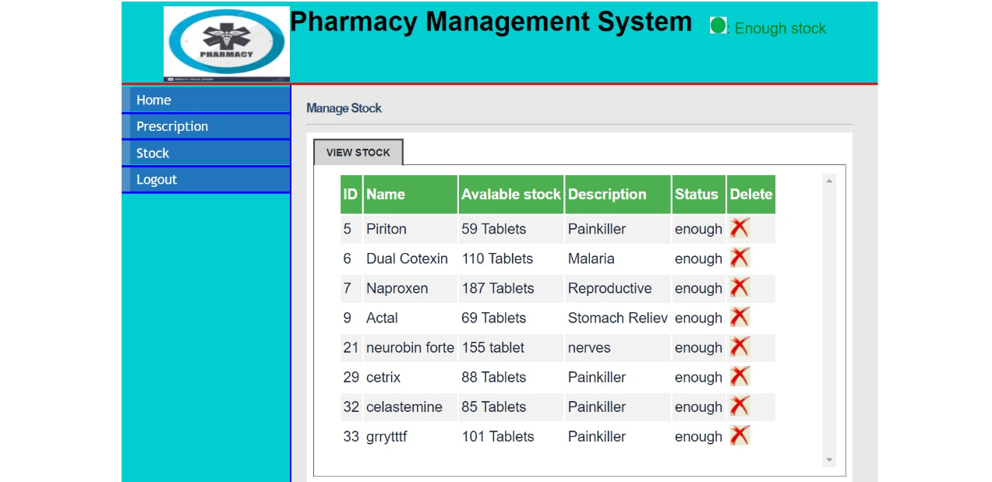

**FIG B.8 Casheir Home Page**

## B.9 CASIER PAYMENT PAGE

In this payment page using invoice Id they can view the temporary prescription and can pay the amount which is shown in Fig B.9

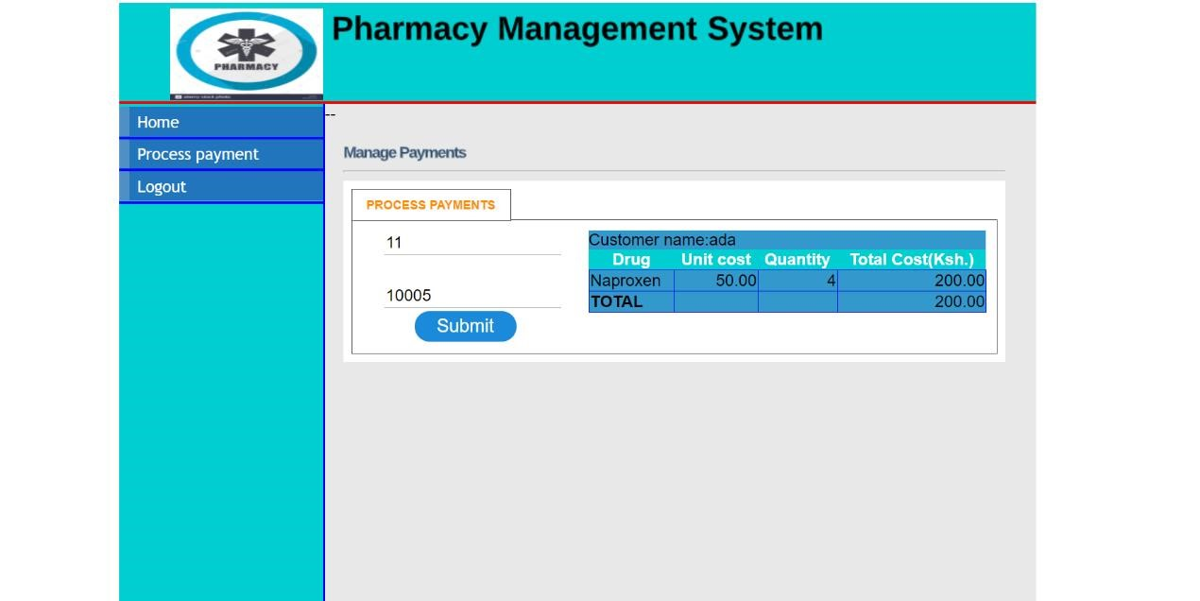

**FIG B.9 Cashier Payment Page**

## CONCLUSION

Pharmacy management system is actually a software which handle the essential data and save the data and actually about the database of a pharmacy and it's management.This software help in effectively management of the pharmaceutical store or shop.It provide the statistics about medicine or drugs which are in stocks which data can also be updated and edited.It works as per the requirement of the user and have options accordingly.It allow user to enter manufacturing as well as the expiry date of medicine placing in stock and for sales transaction.This software also have ability to print the bill and invoices etc.The record of suppliers supplies can also be saved in it.There are other function available too . The main purpose is effectively and easily handling of pharmacy data and it's management.